
INSTRUCTIONS FOR COMPLETING THE
SLOCAN VALLEY LEGACY FUND
BUDGET TEMPLATE

Before working on the Budget Template, you will need to have the following information available:

- Amount of grant being requested from SVLF
- Amount of other funds for the project from all other sources, including any in-kind contributions
- Anticipated expenses to be paid from the SVLF grant
- Anticipated expenses to be paid from other sources of funding

Steps in completing the Budget Template:

- Gather information as above
- Download the Budget Template from the online application form
- Identify sources of project revenue
- Identify anticipated project expenses
- Balance the budget
- Submit the completed Budget Template to your online application
If you encounter difficulties, contact Ellen Kinsel, ekinsel@netidea.com, for assistance.

Download the budget template using the link embedded in the online grant application form.
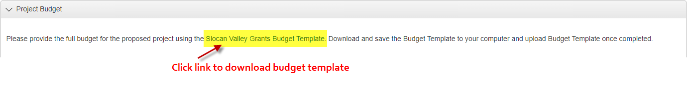

Save the budget template on your computer in a location where you can easily find it.

General Instructions

- This is a spreadsheet file with automatic calculations of line and column totals. These formulas are in the yellow highlighted cells. If you try to enter data into these cells, you will see this error:
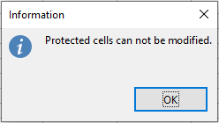

- Revenues and expenditures for the entire project should be provided.
- Save often as you enter information into the template.

Identify Anticipated Project Expenditures

Categories for expenditures include:
- Administration: These are the costs for carrying out the project such as a fee to a sponsor organization, postage or other office expense.
- Wages and Contracts: Staffing costs to carry out the project (employees, contractors, honoraria, etc.).
- Promotion/Marketing: Costs for advertising related to your project.
- Supplies/Materials: Costs for the materials and supplies needed to complete your project.
- Equipment Purchase: If your project includes the purchase of equipment, list it here.
- Other Expenses: Anything not included in the above categories.

The Total Project Expenses will automatically calculate as you enter amounts.

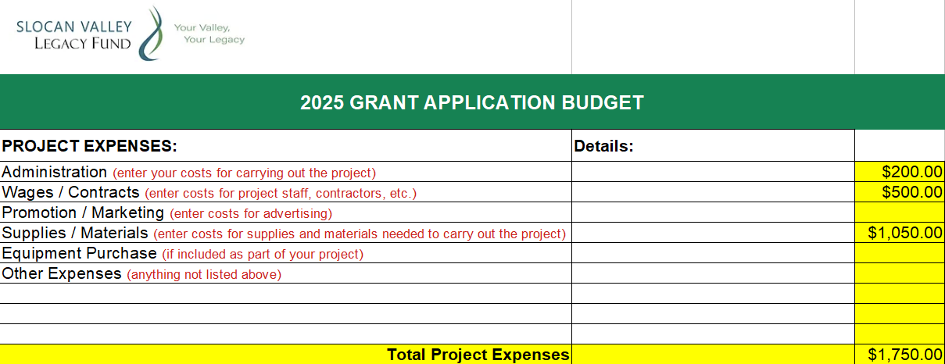

Identify Sources of Project Revenue
- Enter the amount requested from the Slocan Valley Legacy Fund.
- If additional sources of revenue are required to complete your project, enter those sources (e.g., CBT, RDCK, CKCA, organization’s own contribution from cash reserves, etc.) and the amount from each source.
- Enter the value of any expected in-kind contributions. These are contributions that are not received in cash, but cover expenses that ordinarily would have to be paid out in cash. For example, if someone contributes machine work or labor included as an expense cost for which he does not wish to be paid.
- The total amount of revenue will automatically calculate. This should equal the total expected cost of your project.

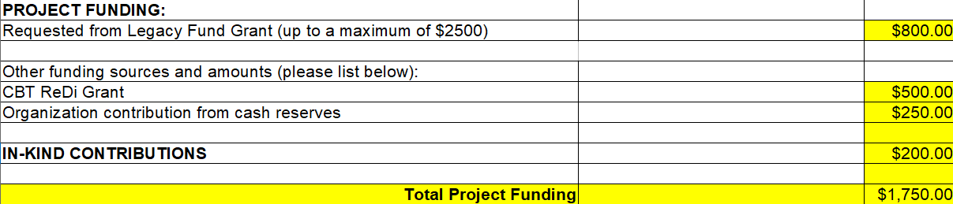

Balancing Your Budget

As indicated, total project expenses must equal total project funding. If these amounts are not equal, make adjustments to either expenditure amounts or funding amounts until they are equal.

Saving the Budget

Save the completed budget template to your computer.

Submitting Your Budget

In the online application form, click


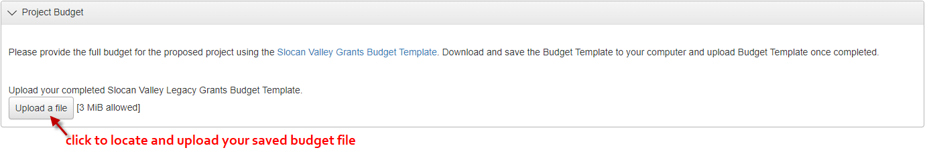

Locate your saved budget file and select it.

Be sure the online application indicates your budget file has been uploaded.

